Assembly instructions
(I am not great at instructions so bear with me, This is not finished)

1: |  | Preparation:  Print all 3D models  (Order doesn’t matter if you print them all first but for the instructions go in this order and assemble when available, Z-axis, Y-axis, X-axis, Light mount, tray mounts, trays, Electrical box)  - Solder straight pins to ToF sensor  Press fit 22 bearings into:  Z2 – 8 bearings  Z3 – 6 Bearings  Y – Motor mount – 2 each  Y – Stabilizer – 2 each  Tap all frame piece ends with a 6mm tap
2: | 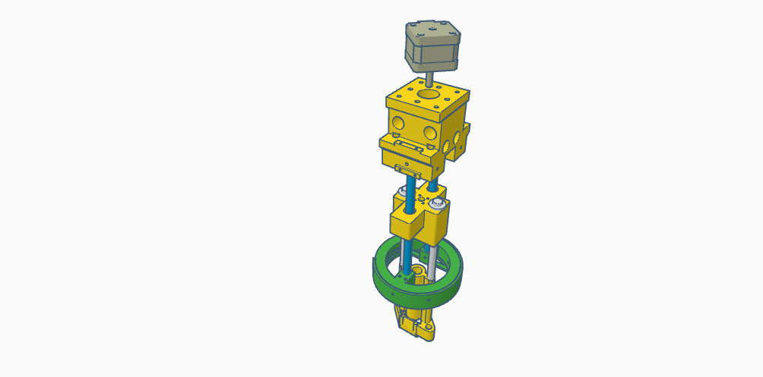 | Assembling the Z-axis:  Top  1. Attach 5mm to 8mm coupler to motor  2. Attach screw rod to coupler  3. Bolt motor to Z1 using four 3mm x 15mm bolts  4. Bolt motor assembly to Z2 using four 5mm x 15mm bolts  5. Insert 2 lengths of 8mm rod x 300mm into the underside of Z2 and secure with six 5mm x5mm set screws. (I took an extra rod and cut it)  Bottom  1. Bolt the screw rod nut that came with the kit to Z3 using four 3mm x 10mm bolts (4)  2. Insert the two shoulder bolts into Z3, add flange washer, a piece of stretched out spring, another flange washer to contain it and thread into Z4  3. Bolt Z5 to Z4 using two 6mm x 15mm bolts  4. Attach ToF sensor to Z5 using tiny screws (I don’t remember size but they are very tiny)  5. Attach wires to camera and mount to Z5 using very small zip ties with 5mm of air hose as a cushion between Z5 and the camera (zip tie goes through the air hose too)  Both camera wires and ToF wire should run between Z4 and Z5 openings  6. Thread suction cups into the holes of Z5, connect the two with a piece of air hose long enough so that it curves each connection about 45 degrees  7. Slide both assemblies onto the rods you inserted into Z2 by manually turning the screw rod through the nut, the larger hole should be down and the long edge on the side for the endstop to touch  8. Insert the two lights into the light mounts, bolt it shut, slide it onto the end of the two rods and bolt it to the rods using two 5mm x 30mm bolts. This will also prevent two two assemblies from accidentally coming apart
3: | 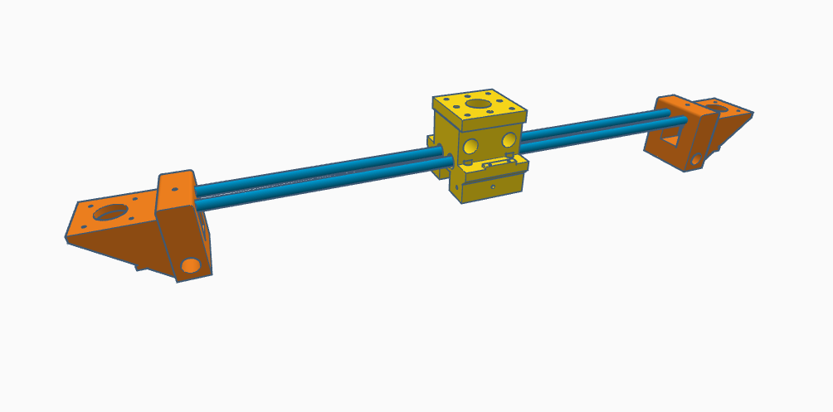  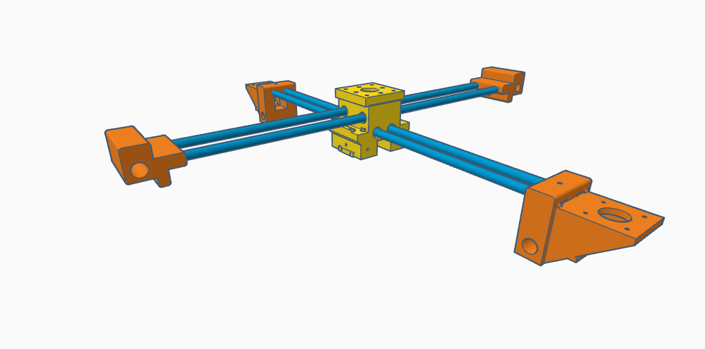 | Traveling Rods:  1. Insert two 550mm rods into the bottom bearing in Z2 and attach Y-axis motor mounts at the ends  2. Insert two 550m rods into the top bearings in Z2 and attach the two stabilizers
4: | 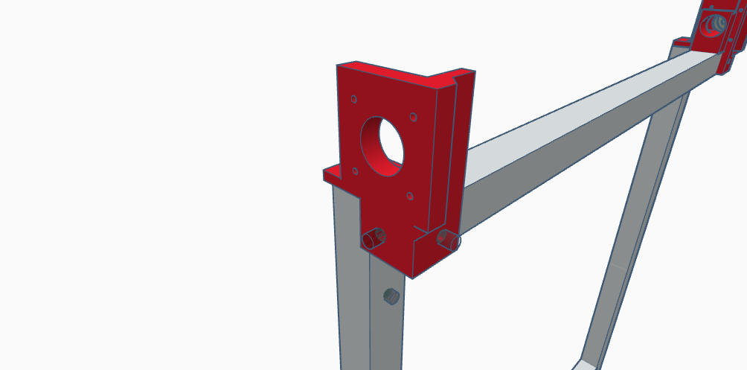  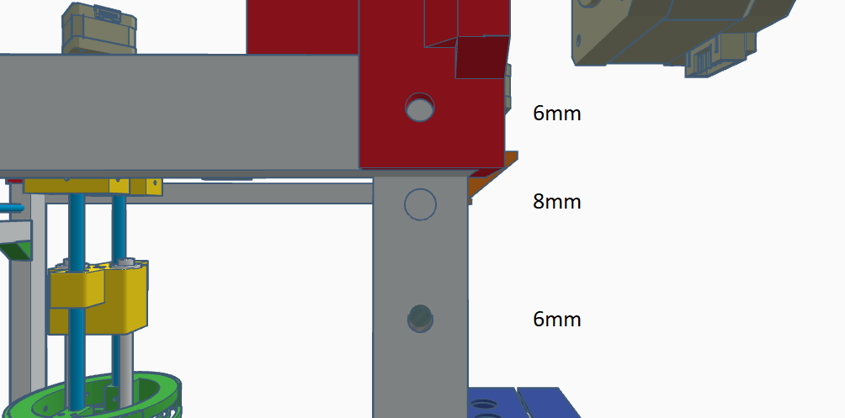  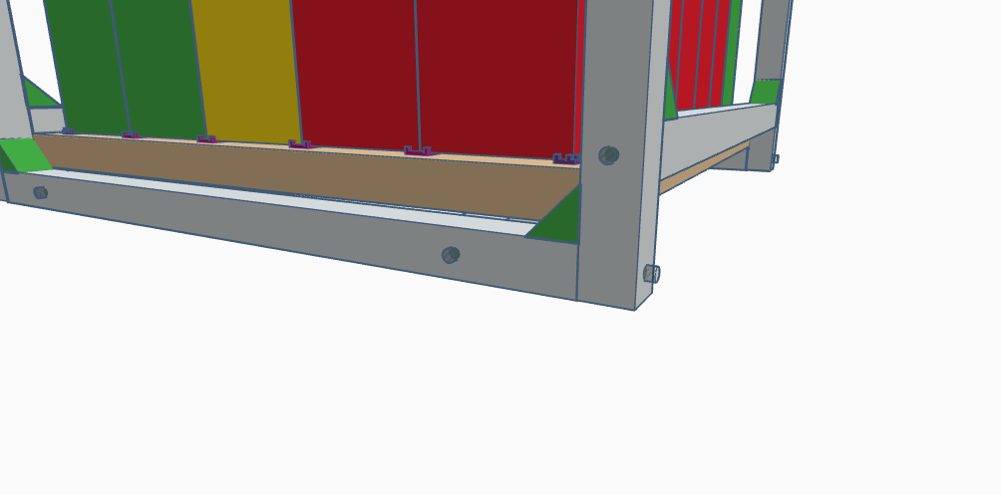 | Assembling the frame:  1. Arrange two 550mm frame pieces and secure with one 6mm x 30mm bolt in the vertical frame and a 6mm x 10mm bolt in the horizontal frame.  2. For the 3rd hole drill a 6mm hole completely through the horizontal frame piece using the printed piece as a guide.  3. Slide a 6mm T-nut down the track and secure the 2 pieces together with a 6mm x 30mm bolt  4. 20mm down from these hole drill another hole 8mm wide on the same side  5. Another 30mm down (50mm total at this point) drill a 6mm hole  6. 60 mm from the opposite end drill a 6mm hole on the same side  7. 12.5mm from the end on the adjacent side drill another 6mm hole  - Repeat these steps for all four vertical frames  8. For each of the 3rd holes down and bottom hole bolt a 500mm frame piece between them using a 6mm x 50mm bolt. You should have a cube shape at this point  9. On both bottom horizontal frame pieces drill a 6mm hole 60mm from each end and add two more 500mm frame sections. This is what the wood base will sit on  10. From here add all your corner brackets (represented by the green triangles in Tinkercad, you will have to unthread some bolts to slide them in and bolt them back down  11. Loosen the 6mm x 30mm bolt on the vertical frames and insert a 550mm rod into each the 8mm frame holes you drilled earlier and join the first assembly onto these rods and re-tighten the bolts. These bolts will hold these rods in place  12. Slide a 500mm rod within the Y-axis stabilizers  13. Bolt the 2 X-axis motors to the X axis motor mounts using four 3mm x 15mm bolts each (I think) with a belt pulley (with set screw with the set screw closest to the motor), coupler, the 500mm rod from step 12, coupler, pulley. Tighten all set screws and bolts  14. For the 2 other X-axis mounts use a 5mm bolt to attach the idler pulleys on each end and another 500mm rod between them. This rod will go though the other Y-axis stabilizer. Tighten all bolts
5: |  | 1. Add the 2 Y-axis motors with a set screw pulley on each  2. Remove the Z-axis motor and traveling screw  3. Attach all belts tightly and clamp down using the belt clamps on top of the Y-axis motor mounts and within Z2. Make sure the 2 X-axis belts are the same length.  4. If the 2 motors are shifted on the belts loosen the belt pulley set screw on one end and slide everything to one end of the machine until they are straight. Re-tighten the set screw  5. Add belt tensioner springs to the belt. Move the X-axis assembly back and both the make sure the springs won’t jam up anywhere  6. Reattach Z-axis motor and traveling screw  7. Attach all 3 endstops and slide your axes to make sure they tough them
6: | 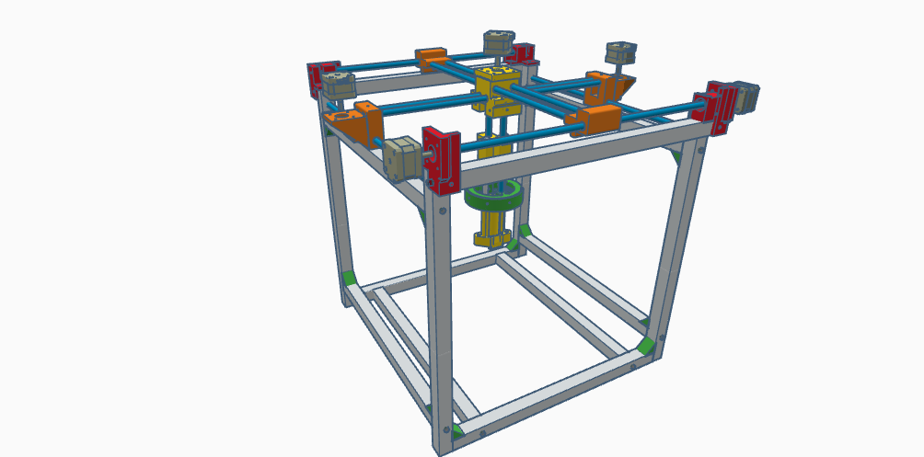 | **You should now have an assembly that looks like this with belts, pulleys and endstops**
7: | 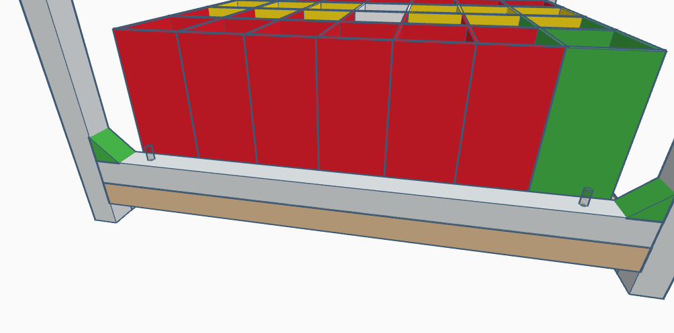  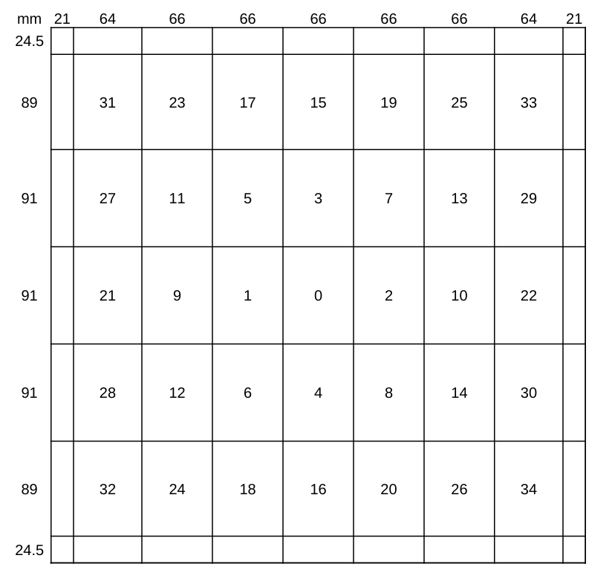 | - Drill 4 holes into the base frame and Center a 550mm x 500mm piece of wood on the bottom and secure it with four #8 2-inch screws  - Draw the grid on the wood, numbers on the outside are in mm, each number is the middle represent the tray number within the Arduino code.  - At each intersecting line drill a 2mm hole (ish), attach all tray aligners at these points with 48 M5 x 10mm tapered wood screws. Do not over tighten  - Mount all trays, the trays are not screwed down. In the event that an unlikely error occurs and it travels in an unpredictable manner the trays will give way instead of breaking them.
8: | 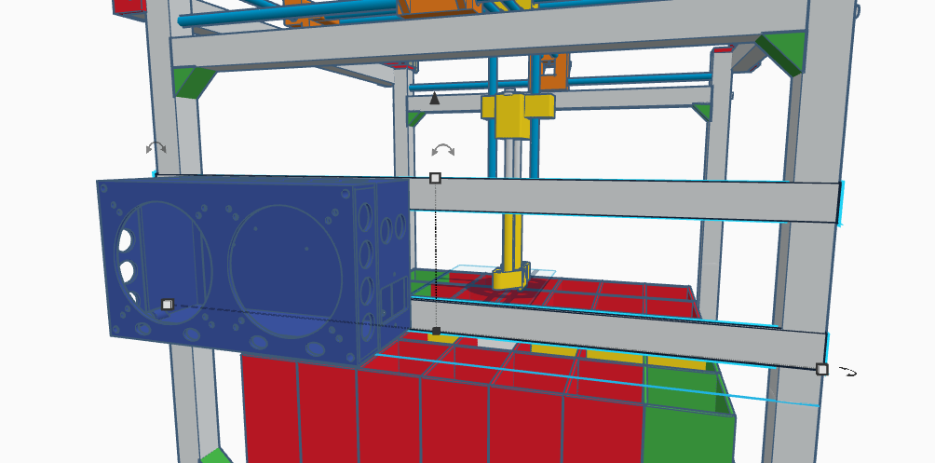 | Electrical box:  - One on side of the robot attach two 550mm sections of the Zinc-Plated perforated steel, mount the electrical box using four 6mm x 10mm bolts and four 6mm nuts  - Bolt the power supply to the empty side using three 4mm x 10mm bolts and three 4mm nuts with the electrical outputs toward the electrical box  - Bolt the Relay and power switch into the electrical box using six 3mm x 10mm bolts  - Bolt the Arduino into the electrical box using three 3mm x 10mm bolts, attach Ramps board and bolt the other 3 holes that line up with the Arduino Mega with 3mm x 20mm bolts
9: |  | Wiring:  Refer to wiring diagram in GitHub and Wiring.ods  Now unplug the connection to Ramps and power on your power supply, using a volt meter adjust the voltage using the small dial until it reads between 11.8V and 12V. Do not exceed 12 volts. I keep mine right at 12 with no issues
10: |  | Code:  1. Install all Python requirements and a program called Arduino IDE  2. Plug the Arduino Mega into your computer using the USB cable that it came with and launch Arduino IDE by double clicking the ino file. Select Arduino Mega and the COM port in which you are plugged into (Make a note of this com port as it will be different for each USB port on your computer)  3. Within the Python config file change the SERIAL_PORT to your com number
11: |  | If you are confident you did everything correctly power it on. If it runs the home machine function flawlessly you should be good. If you hear your motors grinding you did something wrong which could either be something is not straight, your X-axis belts are uneven, or you wiring is wrong. This grinding is not damaging but you should shut it off and look everything over.  If you hear a loud pop… congratulations you wired it backwards or had your voltage way too high and fried something (I claim no responsibilities for any damages).  At this point you should be able to load cards and run the Main.py python script. It may take awhile to load and look idle at first depending on your computer specs. If the python script immediately closes you likely missed a dependency.

